Cryptography - Week 9
digital signature
A digital signature is a mathematical technique used to validate the authenticity and integrity of a message, software or a digital document.
It ensure:
- that the sender of the message is real (authentication);
- that the sender cannot deny that they sent the message (non-repudiation);
- that the message has not been altered since it was sent (integrity).
Hash
The hash functions are algorithms that takes any input (like text, a password, or a file) and turns it into a fixed-length code (letters and numbers).
The same input always gives the same hash, but even a tiny change in the input creates a completely different hash.
How Digital Signatures Work
Create a Hash: the signature software creates a one-way hash of the electronic data that needs to be signed.
Encrypt the Hash: Your private key (a secret code only you know) encrypts this hash.
Form the Signature: The encrypted hash + some extra details = your digital signature.
How to Verify a Digital Signature
Someone else can check your signature using your public key (a code everyone can see).
They:
- Decrypt the hash using your public key.
- Calculate a new hash from the received data.
- Compare the two hashes:
- If they match → The data wasn’t changed, and the signature is real.
- If they don’t match → Either the data was altered, or the signature is fake.

There are two main types of digital signatures:
1. Direct Digital Signature
Only involves the sender and receiver.
The sender signs the message directly using their private key.
The receiver verifies it using the sender’s public key.
Pros:
Simple and fast.
Cons:
If the sender’s private key is stolen, fake signatures can be made.
No third party to help if there’s a dispute.
2. Arbitrated Digital Signature
Uses a trusted third party (arbitrator).
Before sending a message, the sender gives it to the arbitrator.
The arbitrator checks and confirms the sender’s identity, then adds its own digital signature.
The receiver trusts the message because the arbitrator approved it.
Pros:
More secure—harder to fake.
The arbitrator can help resolve disputes.
Cons:
Slower because it depends on the arbitrator.
Requires trust in the arbitrator.
Requirements of Digital Signature
- Must be bit-pattern and depends on message
- Must send some unique info to avoid forgery & denial
- Must be easy to produce
- Recognition and verification should be easy
- Should be computationally infeasible to reproduce
- A copy should be retained in DS storage

digital certificate
A digital certificate is an electronic document used to authenticates the identity of a website, individual, organization, user, device or server. It is also known as a public key certificate or identity certificate.
TLS/SSL certificates(Transport Layer Security / Secure Sockets Layer): The TLS/SSL certificate is used to secure communications between a computer and the server, and it is hosted by the server. When a client computer seeks to access the server, the server will present the digital certificate to prove that it is authentic and the desired destination.
Client certificates: This is a form of a digital ID that can identify one machine to another — a specific user to another user. This can be used to allow a user to access a protected and secure database and also for email.
Code signing certificates:
Used by software developers to sign software or apps.
Proves that the software hasn’t been tampered with and is from a trusted source.
Helps users trust downloads and updates.

Distribution of Public Keys
Because public keys are essential for encryption and authentication, secure and reliable distribution is critical. There are several methods to do this:
- Public Announcement
  - The public key is broadcast or shared openly (e.g., on a website or in a document).
  - Risk: easy to impersonation or man-in-the-middle attacks.
- Publicly Available Directory
  - A trusted central directory (like LDAP) where users can look up public keys.
  - Example: Key servers for PGP.
  - Requires protection from unauthorized changes.
- Public-Key Authority
  - A trusted third party manages and provides public keys upon request.
  - Verifies the identity of the requester before releasing the public key.
  - Requires secure communication with the authority.
- Public-Key Certificates
  - The most secure and scalable method.
  - A trusted Certificate Authority (CA) issues a digital certificate that links a user’s identity with their public key.
  - The certificate is signed by the CA
  - Users validate the certificate using the CA’s public key.
  - Used in PKI (Public Key Infrastructure) systems.

Cryptography - Week 10-11

Cryptographic Hash Functions
Cryptographic hash functions are a fundamental part of modern cryptography. They take an input (or "message") and return a fixed-size string of bytes — typically a digest that appears random. These functions have several important properties that make them useful in security applications like digital signatures, message authentication, and password hashing.

Key Properties
A cryptographic hash function must satisfy the following properties:
- Deterministic
  - The same input always produces the same output.
- Fast Computation
  - It should be quick to compute the hash for any given input.
- Pre-image Resistance
  - Given a hash value h, it should be infeasible to find an input x such that hash(x) = h.
(This prevents reverse-engineering the original input.)
- Second Pre-image Resistance
  - Given an input x1, it should be infeasible to find another input x2 ≠ x1 such that hash(x1) = hash(x2).
- Collision Resistance
  - It should be infeasible to find any two distinct inputs x1 and x2 such that hash(x1) = hash(x2).
- Avalanche Effect
  - A small change in the input should produce a significantly different output.

Applications:
- Password Hashing
  - Passwords are stored as hash values to prevent unauthorized access even if the database is leaked.
- Digital Signatures
  - The message is hashed before signing to ensure integrity and reduce computational load.
- Data Integrity
  - Hashes are used to detect accidental or intentional changes in data (e.g., file checksums).
- Blockchain
  - Every block in a blockchain contains a hash of the previous block, ensuring tamper-resistance.

Hash Function Usages
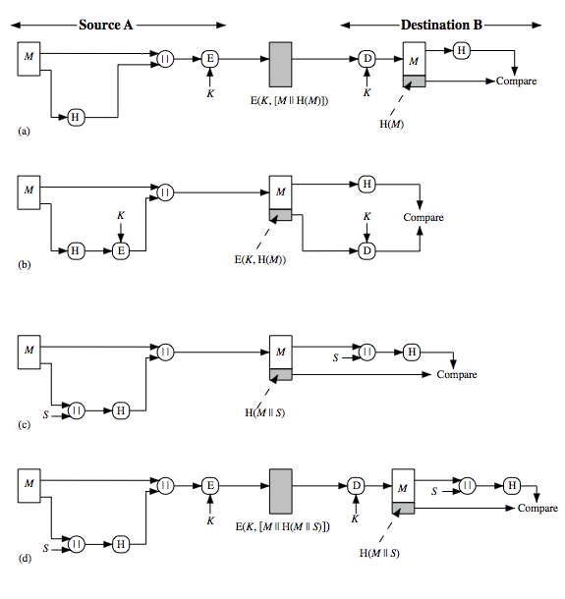
- The message plus concatenated hash code is encrypted using symmetric encryption. Since only A and B share the secret key, the message must have come from A and has not been altered. The hash code provides the structure or redundancy required to achieve authentication.
- Only the hash code is encrypted, using symmetric encryption. This reduces the processing burden for those applications not requiring confidentiality.

(c) Shows the use of a hash function but no encryption for message authentication. The technique assumes that the two communicating parties share a common secret value S. A computes the hash value over the concatenation of M and S and appends the resulting hash value to M. Because B possesses S, it can recompute the hash value to verify. Because the secret value itself is not sent, an opponent cannot modify an intercepted message and cannot generate a false message.
(d) Confidentiality can be added to the approach of (c) by encrypting the entire message plus the hash code.
When confidentiality is not required, method (b) has an advantage over methods (a) and (d), which encrypts the entire message, in that less computation is required.

Merkle–Damgard
The Merkle–Damgard construction is a widely used method to build cryptographic hash functions from a basic building block called a compression function.
A compression function takes a fixed-length input and returns a shorter, fixed-length output.
a hash function can be defined by repeated applications of the compression function until the entire message has been processed.
Take a long message, break it into blocks
M₁, M₂, M₃…M_{k} (pad out last block)

Step-by-Step Structure
- Message Padding
  - Pad the original message so that its length becomes a multiple of the block size (e.g., 512 bits).
  - Padding includes appending the original message length to the end (for collision resistance).
- Break Into Blocks
  - Split the padded message into k blocks:
M1, M2, M3, ..., Mk
- Initialize State (IV)
  - Set an initial chaining value (called the initialization vector, IV).
This is usually a fixed, predefined constant.
- Iterative Compression
sequentially process blocks
• The hash from the previous block (called the "chaining value")
• The current message block

- Final Output
  - The output of the last compression hk is the final hash (message digest).

Attacks on Hash Functions

1. Brute-Force Attacks
- Try all possible inputs until a match is found.
- Slow and depends only on hash length (e.g., 2<sup>128</sup> attempts for a 128-bit hash).

2. Cryptanalysis
- Finds weaknesses in the hash algorithm.
- Much faster than brute-force if a weakness is found.
- Focuses on the compression function used in hash functions.

Common Attack Types

Preimage Attack
- Find input x such that H(x) = h (a given hash).
- Hard: needs ~2<sup>m</sup> tries (for m-bit hash).

Second Preimage Attack
- Given x, find y ≠ x so that H(y) = H(x).
- Also needs ~2<sup>m</sup> tries.

Collision Attack
- Find any two different messages x ≠ y such that H(x) = H(y).
- Easier than the above due to the birthday paradox: needs ~2<sup>m/2</sup> tries.

How Cryptanalysis Works
- Hash functions work by processing the message in blocks.
- A compression function f is used repeatedly.
- Cryptanalysts try to find collisions in f, which can break the entire hash.

Real-World Impact
- Weak hashes (like MD5, SHA-1) are no longer safe.
- Secure hashes (like SHA-256, SHA-3) are recommended.

Web Security - Week 15

Cross-site scripting (XSS) is an attack in which an attacker injects malicious executable scripts into the code of a trusted application or website.
Attackers often initiate an XSS attack by sending a malicious link to a user and tricks you into clicking it.
If the app or website lacks proper data sanitization, the malicious link executes the attacker’s chosen code on the user’s system. As a result, the attacker can steal the user’s active session cookie.

Understanding XSS Vulnerability Attacks
Cross Site Scripting or XSS can happen in many ways.
- For example, an attacker may present you with a malicious website looking like its original and ask you to fill in your credentials.
- When your browser sends its cookies over to the malicious website, the attacker decodes your information and uses it to impersonate you at the original site.
- This is a targeted attack and is called non-persistent in technical terms.
- Websites and web applications usually send a cookie to identify a user after he/she has logged in.
- For every action from the user on the site, the user's browser has to resend the cookie to the web application as identification.
- If an attacker is able to inject a Cross-site Scripting (XSS) payload on the web application, the malicious script could steal the user's cookie and send it to the attacker.
- The attacker can then use the cookie to impersonate the user in the web application.
- The most dangerous variation of XSS is persistent, or stored XSS.
- This is because the attacker’s XSS payload gets stored and served to each visitor accessing the website or web application without any user interaction.

What Can an Attacker Do with Malicious JavaScript?
JavaScript has powerful access to your browser. When a hacker injects malicious JavaScript into a website. Here’s what they can do:
1. Steal Your Cookies & Sessions
JavaScript can read your session cookies, letting the attacker log in as you (e.g., on Facebook, Gmail, or banking sites).
2. Modify the Web Page (DOM Manipulation)
JavaScript can change anything on the page—like adding fake login forms or malicious links.
3. Send Fake Requests (Using Your Account)
JavaScript can make HTTP requests (like fetch or XMLHttpRequest) to perform actions as you.
4. Spy on You (Webcam, Microphone, Location, Files)
If you granted permissions earlier, JavaScript can access:
Location (GPS) → navigator.geolocation.getCurrentPosition()
Webcam & mic → navigator.mediaDevices.getUserMedia()
Files → Using FileReader API (if you upload something).
5. Redirect You to a Fake Website
redirect the browser to another web page, for example, one that contains malicious code.
6. Keylogging (Track Everything You Type)
JavaScript can record your keystrokes, stealing passwords & credit card info.

How XSS Attacks Work:
- Injection: An attacker finds a vulnerability in a web application that allows them to insert malicious code into a part of the website that will be displayed to other users. This could be in a comment section, a search bar, a user profile field, or even a URL parameter.
- Execution: When another user visits the compromised page, their browser executes the malicious script. The browser has no way of knowing the script is malicious because it appears to come from the same trusted origin.
- Impact: Once executed, the malicious script can do anything that the site's own code can do within the user's browser, including:
Steal Your Cookies & Sessions
JavaScript can read your session cookies, letting the attacker log in as you (e.g., on Facebook, Gmail, or banking sites).
Modify the Web Page (DOM Manipulation)
JavaScript can change anything on the page—like adding fake login forms or malicious links.
Send Fake Requests (Using Your Account)
JavaScript can make HTTP requests (like fetch or XMLHttpRequest) to perform actions as you.
Spy on You (Webcam, Microphone, Location, Files)
If you granted permissions earlier, JavaScript can access:
Location (GPS) → navigator.geolocation.getCurrentPosition()
Webcam & mic → navigator.mediaDevices.getUserMedia()
Files → Using FileReader API (if you upload something).
Redirect You to a Fake Website
redirect the browser to another web page, for example, one that contains malicious code.
Keylogging (Track Everything You Type)
JavaScript can record your keystrokes, stealing passwords & credit card info.
Types of XSS Attacks:
There are three main types of XSS:
- Stored XSS (Persistent XSS): This is the most dangerous type. The malicious script is permanently stored on the vulnerable server (e.g., in a database). Every time a user accesses the compromised page, the malicious script is delivered to their browser and executed. Examples include malicious comments on a blog or forum posts.
- Reflected XSS (Non-persistent XSS):
The malicious script is part of a URL or form and gets reflected (sent back) by the server in the response.
The attacker needs to trick the user into clicking this malicious link. When the victim clicks a crafted malicious link.
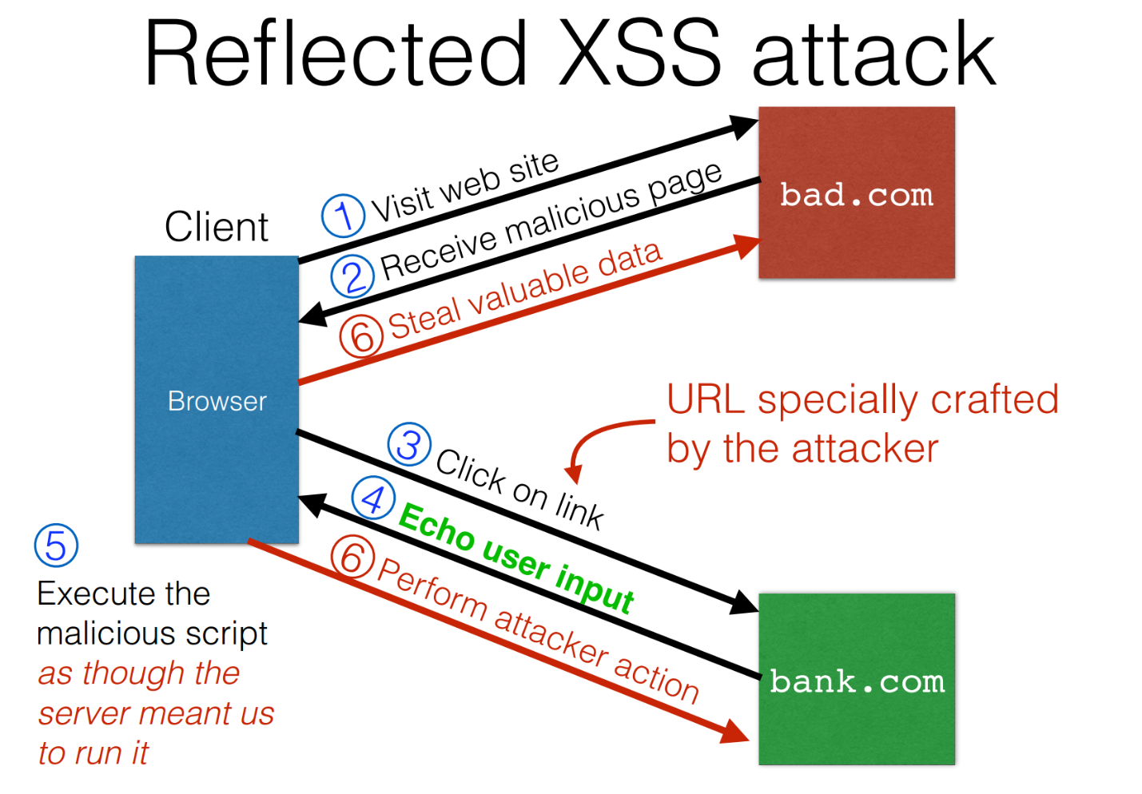

Preventing XSS
- Train and maintain awareness
- Don’t trust any user input
- Use escaping/encoding
- Sanitize HTML
- Set the Http Only flag for cookies
- Use Content security policy
- Scan Regularly using Web Vulnerability scanners

CSRF (Cross-Site Request Forgery) is a type of web security vulnerability that tricks a victim into performing actions on a website without their knowledge or consent — while they are authenticated on that site.

🔐 Simple Explanation:
Imagine you're logged into your bank website. While you're still logged in, you click on a malicious link in an email or another site. That link secretly sends a request to your bank to transfer money, and because you're already logged in, the bank thinks you made that request.

📌 How CSRF Works:
- User logs into a trusted site (e.g., a bank) and gets a valid session (usually stored in cookies).
- Attacker tricks the user into visiting a malicious site while the session is still active.
- The malicious site sends a forged request to the bank using the user's browser and session cookies.
- The bank receives the request and thinks it came from the legitimate user — action is performed (e.g., money transfer).

🧠 Key Requirements for CSRF:
- User is authenticated (session cookie exists).
- Website does not properly verify where the request is coming from.
- Attacker knows what kind of request to send.

✅ CSRF Prevention Techniques:
- CSRF Tokens: - A CSRF token is a unique, secret, and unpredictable value that is generated by the server-side application and shared with the client. When attempting to perform a sensitive action, such as submitting a form, the client must include the correct CSRF token in the request. This makes it very difficult for an attacker to construct a valid request on behalf of the victim
- SameSite Cookies: S SameSite is a browser security mechanism . It helps stop other websites from using your cookies without permission, which protects against some attacks like CSRF.

- Referer-based validation: Server checks the Referer header to see where the request came from.
Can be unreliable — some browsers strip or block Referer headers due to privacy settings.
should not be the only CSRF defense.

Secure Networks Week 14

What is a Firewall?
a firewall is a network security system that monitors and controls incoming and outgoing network traffic based on security rules.

Why Do We Need Firewalls?
- When a company connects to the internet, it gets many benefits, like easy communication and access to online tools.
- But the internet can also bring security threats — hackers can try to steal data or cause harm.
- While every computer in the network can have its own security, it’s not enough and too expensive to manage.
- If a security bug is found, every single computer must be updated — which is hard to manage.
- So, a firewall offers a central and cost-effective solution to protect the whole network from one place.

Main Features of a Firewall (Access Policy):
- All traffic must pass through
- Only authorized traffic will be allowed to pass
- It is protected from attacks

How Does a Firewall Filter Data?
A firewall decides what to allow or block using several rules:
- IP Address and Protocols: Controls access based on the source or destination addresses and port numbers, direction of flow being inbound or outbound, and other network and transport layer characteristics.
- Application Protocols: It checks which application (e.g., YouTube, WhatsApp) is trying to send data and allows only trusted ones.
- User Identity: It can allow access based on who the user is, especially for employees using secure login.
- Network Activity: It can block unusual behavior, like someone trying to access the system late at night or too many requests in a short time.

What Can a Firewall Do? (Capabilities)
- Acts as a single checkpoint to block bad traffic and attacks.
- Helps monitor and record security events (like keeping logs and sending alerts).
- Can also help with other internet services like:
  - NAT (hiding internal IPs)
  - Keeping records (audit logs)
  - Supporting IPSec (a security feature)

What a Firewall Can’t Do (Limitations)
- It can’t stop attacks that come from inside the company.
- It can't protect against devices (like laptops or USBs) that get infected outside and then connect to the company network.
- It won’t help if someone uses an open or weak Wi-Fi network to access the system.

Types of firewall
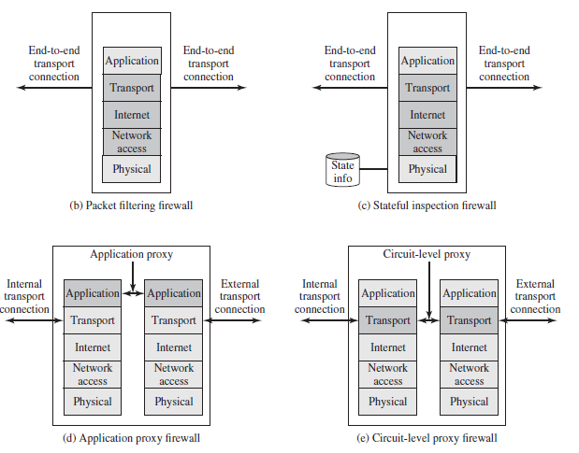

What is a Packet Filtering Firewall?
A Packet Filtering Firewall checks each network packet (tiny piece of data) that comes in or goes out of a computer network.
It uses rules to decide whether the packet should be allowed (forwarded) or blocked (discarded).

📦 What Information Does It Look At?
The firewall looks at details in each packet, such as:
- Source IP Address: Where the packet came from (e.g., 192.178.1.1)
- Destination IP Address: Where the packet is going (e.g., 192.168.1.2)
- Port Numbers: These tell which app or service is used (like HTTP, FTP, or Telnet)
- Protocol Type: Such as TCP or UDP (methods for sending data)
- Network Interface: Which network path (port) the packet is using
It compares this info with its rule list to decide if the packet should be blocked or allowed.

✅ Default Policies
If the packet doesn’t match any rule, the firewall will take a default action:
- Default = Discard: Block everything unless it’s allowed (more secure)
- Default = Forward: Allow everything unless it’s blocked (less secure)

⚠️ Weaknesses of Packet Filtering Firewalls
- ❌Can't See Application Data
It only checks basic info (like IP address and port), not what's inside the packet (e.g., what the user is doing).
- 📉 Weak Logging
It doesn’t record detailed information about traffic, so tracking attacks is harder.
- 🔐 No User Login Support
It can’t check who the user is — so it can’t use advanced user authentication.
- 🕳️ Protocol Weaknesses
Some attackers exploit bugs in the TCP/IP system to bypass the firewall.
- ⚙️ Easy to Misconfigure
If set up wrong, the firewall might allow dangerous traffic by mistake.

💣 Attacks on Packet Filtering Firewalls
- IP Address Spoofing
  - The attacker fakes a trusted internal IP address to trick the firewall.
  - 🛡️ Countermeasure: discard packets with an inside source address if the packet arrives on an external interface
- Source Routing Attack
  - The attacker forces packets to follow a specific path to bypass security.
  - 🛡️ Countermeasure: Block all packets that try to use source routing.
- Tiny Fragment Attack
  - The attacker breaks up the packet into tiny parts so important information (like TCP headers) gets hidden from the firewall.
  - 🛡️ Countermeasure: Make sure the first part of every packet contains enough header info. If not, block it and all its fragments.

🔄 Stateful Packet Inspection Firewall (SPI)
- A regular packet filter checks each packet individually with no memory of past activity.
- A stateful firewall, on the other hand, remembers previous connections (it keeps a list or "state table" of active sessions).
- It checks not only where the packet is from and going to, but also:
  - Is this packet part of a valid, known connection? (Connection state)
  - TCP sequence numbers to stop attacks like session hijacking
- 🛡️ Benefit: More secure than basic packet filters; can block fake or unexpected packets.

🌐 Application-Level Gateway (ALG)
Also called: Application Proxy
- Acts like a middleman for specific apps like FTP, Telnet, or HTTP.
- The user connects to the gateway instead of directly to the internet.
- The gateway then connects to the desired website/app on the user’s behalf.
- It checks:
  - Full app data.
  - Who the user is (username & password)
  - What the user wants to do in the app (e.g., download, upload).
- If the application is not supported by the gateway, it will not be allowed.
🛡️ Benefits:
- More secure because it only allows selected apps and functions.
- Easier to monitor and log activity at the application level.
⚠️ Downside:
- Slower performance — because every bit of data goes through the gateway and is checked.

🔁 Circuit-Level Gateway
- This firewall works at a lower level than application gateways, but higher than basic packet filters.
- It creates two separate TCP connections:
  - One with the internal user.
  - One with the external host (like a website).
- It then just forwards data between them without checking content.
- It only checks if the connection is allowed based on rules.
🛡️ Benefit:
- Faster than application-level gateways.
- Useful when you don't need to check every detail, just control access.
Firewall Type | Checks | Security Level | Performance | Example
Packet Filtering | IP, Port, Protocol | Basic | Fast | IP blocking
Stateful Packet Inspection | IP + Connection state + TCP info | Medium-High | Medium | Blocks fake replies
Application Gateway | Full app data, user login | High | Slower | Web proxy
Circuit-Level Gateway | Allows/denies full connections | Medium | Faster than ALG | SOCKS proxy

Firewall Basing
Firewall basing means where and how the firewall is placed in a network. It decides what kind of protection is used and on which system.

Bastion Host
A strong and secure computer placed at a key point in the network.
- Runs a hardened (secured) version of its OS.
- Only essential services are installed.
- Often used as a gateway and may require extra login checks.

Host-Based Firewall
A host-based firewall is a software module used to secure an individual host.
- Built into many operating systems or added separately.
- Rules can be customized for that specific host.
- Adds extra protection even when used with network firewalls.

Personal Firewall
A firewall on personal computers to control internet traffic.
- Usually software-based and easy to use.
- Blocks unauthorized access and watches for malware.
- Can be part of a home router to protect multiple devices.

1. DMZ Networks (Demilitarized Zone)
A DMZ or demilitarized zone is a perimeter network that protects and adds an extra layer of security to an organization's internal local-area network from untrusted traffic.

2. Distributed Firewalls
- applies firewall policy to all devices in a network.
- Firewalls are spread across multiple points in the network instead of just at the perimeter.
- work directly on each host (server or computer).
- Benefit: More control and security for internal traffic.

3. Virtual Private Network (VPN)
- A VPN encrypts data and creates a secure "tunnel" over the internet.
- Firewalls can be configured to allow or manage VPN traffic.
- Used to secure remote access to private networks.
- Types: Site-to-site VPN (between networks) and Remote-access VPN (for individual users).
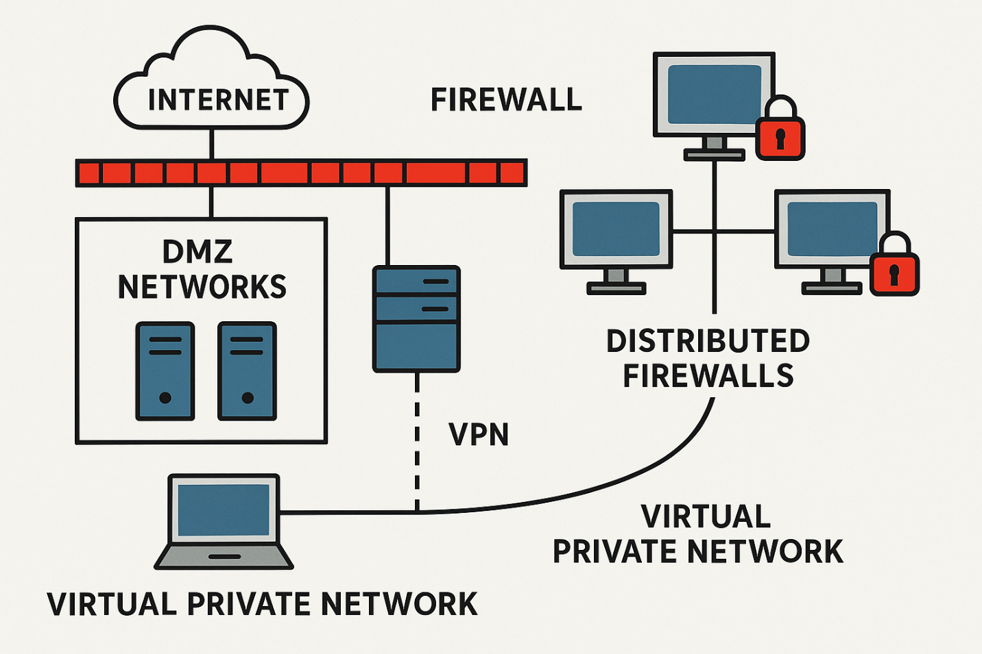

Intrusion Prevention System (IPS)
An IPS is a security tool that monitors network or system activities to detect and prevent malicious actions (like hacking attempts, viruses, or unauthorized access) in real time.

🖥️ 1. Host-Based IPS (HIPS)
- Installed on individual devices (hosts) like servers or PCs.
- Protects the specific system it's installed on.
- Monitors system files, logs, and running processes.
- Great for protecting critical machines.
Example: Antivirus with IPS features installed on a computer.

🌐 2. Network-Based IPS (NIPS)
- Placed in the network, not on a specific device.
- Monitors all traffic going through the network.
- Detects attacks like DDoS, port scans, worms, etc.
- Best for protecting entire network segments.
Example: A hardware IPS box connected to a router or switch.

